Lab - Researching IT and Networking Job Opportunities

Objectives

Part 1: Research Job Opportunities

* Identify the current networking jobs that are in demand.
* Explain the value of Cisco certifications in the job market.

Part 2: Reflect on Research

* Identify current hiring trends in IT/networking.
* Identify future networking career certifications and skills.
* Identify additional networking career paths.

Background / Scenario

Jobs in Information Technology (IT) and computer networking continue to grow. Most employers require some form of industry standard certification, degree, or other qualifications from their potential employees, especially those with limited experience. The Cisco CCNA certification is a known and established entry level networking certification that is respected in the industry. There are additional levels and kinds of Cisco certifications that one can attain, and each certification may enhance employment opportunities as well as salary range.

In this lab, you will do some targeted job searching on the web, to find what types of IT and computer networking jobs are available; what kinds of skills and certifications you will need; and the salary ranges associated with the various job titles.

Required Resources

* Device with Internet access

1. Research Job Opportunities

In Part 1, you will use a web browser to visit the popular job listing web sites monster.com and salary.com.

* 1. Open a web browser and go to a job listing website.

In the URL address bar type in <http://monster.com> and press Enter.

**Note**: For job listings outside of the US, use the following link to search for your country:

<http://www.monster.com/geo/siteselection/>

* 1. Search for networking related jobs.
     1. Type the word *Network* in the Job title box. Notice that the website offers context sensitive suggestions based on the keywords provided. Either click on, or finish typing the words, *Network Administrator* and click the **SEARCH** button (see image below).

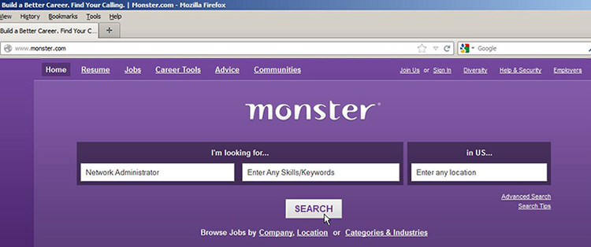

* + 1. Notice the search results:

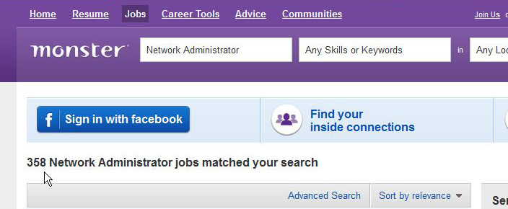

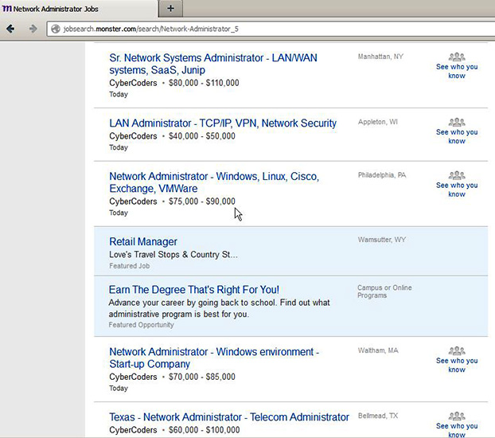

* + 1. Now focus your search by adding terms to the keywords field box. Try terms like Cisco CCNA, CCNP, CCNA Security, CCNA Voice, etc.
    2. Now try refining your search by adding in different geographical locations. Did you find jobs in the locations you entered?

____________________________________________________________________________________

* + 1. Try searching a different website. Go to <http://salary.com> and click the **Job Search** menu bar button.

**Note**: For salary listings outside of the US, use the following link to search for your country:

<http://www.payscale.com/rccountries.aspx>

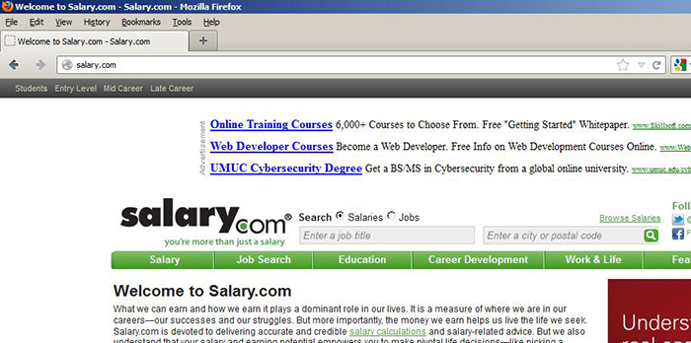

* + 1. Now add a search term like *Information Technology* to the job title field box and click **Submit**.

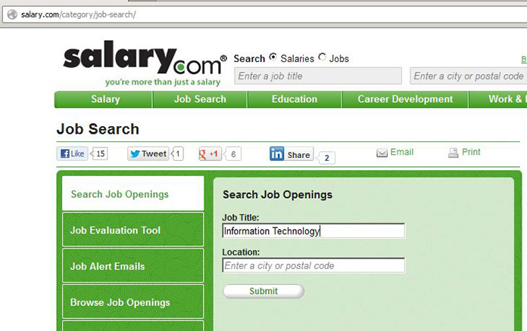

* + 1. In the image below, note the large number of matching search results. There are also easy to use tools for refining your search, in the column to the left.

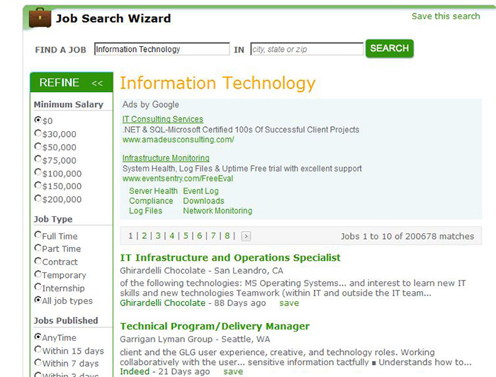

* + 1. Spend some time searching for jobs and looking through the search results. Take note of what skills are required for different job titles and the range of starting salaries.

1. Reflect on Research

In Part 2, you answer questions based on your research findings.

* + 1. What job titles did you search for?

____________________________________________________________________________________

____________________________________________________________________________________

* + 1. What skills or certifications were required?

____________________________________________________________________________________

____________________________________________________________________________________

* + 1. Did you find any jobs that you previously did not know existed? If so, what were they?

____________________________________________________________________________________

____________________________________________________________________________________

* + 1. Did you find any jobs that you are interested in? If so, which ones and what skills or certifications do they require?

____________________________________________________________________________________

____________________________________________________________________________________

____________________________________________________________________________________